|  |  |  |  |
| --- | --- | --- | --- |
| **Input** | **Required Result** | **Required Processing** | **Solution Alternatives** |
| Age | if user meets minimum age or not | If age < 0 → Invalid Age  If age < 18 → Ineligible  If age >= 18 → proceed | Stop if requirement don’t meet  Else continue |
| Eyesight Test (P/F) | If user eyesight meets according to requirement | If F → need prescription for glasses  If P → proceed | Stop if need prescription  Else Continue |
| Written Test (P/F) | If user understands road rules | If F → retake  If P → proceed | Stop if failed  If passed Continue |
| Driving Test (P/F) | If user drive safely | If F → Ineligible  If P → proceed | Stop if failed  If passed Continue |
| Medical Certificate (Y/N) (only age ≥ 60) | Confirm medical fitness for older user | If N → not eligible  If Y → Eligible | Stop if no certificate If yes Continue |

**PAC CHARTS:**

**IPO CHARTS:**

|  |  |  |
| --- | --- | --- |
| **Input** | **Processing** | **Output** |
| Age  Eyesight test(P/F) Written test (P/F) Driving test (P/F) - Medical certificate (Y/N if ≥60) | Check age, Eyesight, Written, Driving test  Check test results  If age ≥60 check medical certificate | Validity and Invalidity Display according to user Input  Eligibility and Ineligibility  According to Conditions |

**Algorithm:**

1. Start
2. OUTPUT "DRIVING LICENSE FORM"
3. OUTPUT “Enter your age:"  
   Input age
4. If age < 0  
   OUTPUT “Invalid Age"  
   Stop
5. If age < 18  
   OUTPUT "You are Ineligible"  
   Stop
6. OUTPUT "Have you passed the eyesight test? (Press P for pass and F for fail):"  
   Input Eyesight test
7. If Eyesight test = 'F'  
   OUTPUT “Need prescription for glasses"  
   Stop
8. OUTPUT “Have you passed the written test? (Press P for pass and F for fail):"  
   Input written test
9. If written test = 'F'  
   OUTPUT"GIVE A RETAKE!!"  
   Stop
10. OUTPUT "Have you passed the driving test? (Press P for pass and F for fail):"  
    Input driving test
11. If driving test = 'F'  
    OUTPUT "Ineligible because you did not passed the driving test."  
    Stop
12. If age < 60 then  
    OUTPUT "You are eligible for the license"  
    Stop
13. Else (age ≥ 60):  
    OUTPUT "Do you have a medical fitness certificate? (Press Y for yes and N for No):"  
    Input Medical Certificate
14. If Medical_Certificate = 'N'  
    OUTPUT "Not eligible"  
    Stop
15. Else  
    OUTPUT "Eligible"  
    Stop
16. End

**PSEUDOCODE:**

DECLARE eyesightexam, writtentest, drivingtest, medicalcertificate as CHAR

DECLARE age as INTEGER

OUTPUT ("DRIVING LICENSE FORM")

OUTPUT ("Enter your age: ")

INPUT (age)

IF age < 0 THEN

OUTPUT ("Invalid Age")

RETURN 1

ENDIF

IF age < 18 THEN

OUTPUT("Ineligible")

RETURN 1

ENDIF

OUTPUT ("Have you passed the eyesight test? (Press P for pass and F for fail): ")

INPUT (eyesightexam)

IF eyesightexam = 'F' THEN

OUTPUT ("Need prescription for glasses!!")

RETURN 1

ENDIF

OUTPUT ("Have you passed the written test? (Press P for pass and F for fail): ")

INPUT (writtentest)

IF writtentest = 'F' THEN

OUTPUT ("GIVE A RETAKE!!")

RETURN 1

ENDIF

OUTPUT ("Have you passed the driving test? (Press P for pass and F for fail): ")

INPUT (drivingtest)

IF drivingtest = 'F' THEN

OUTPUT ("Ineligible because you did not passed the driving test.")

RETURN 1

ENDIF

IF age < 60 THEN

OUTPUT ("You are eligible for the license")

RETURN 1

ELSE

OUTPUT ("Do you have a medical fitness certificate? (Press Y for yes and N for No): ")

INPUT (medicalcertificate)

IF medicalcertificate = 'N' THEN

OUTPUT ("Not eligible")

RETURN 1

ELSE

OUTPUT("Eligible")

RETURN 0

ENDIF

ENDIF

**CODE:**

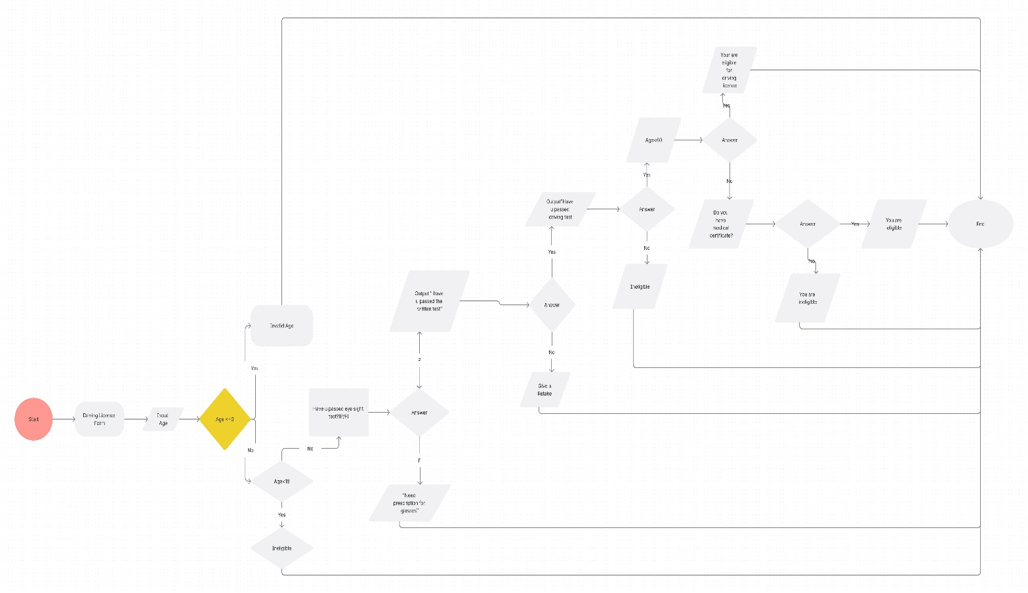**FLOWCHART:**